Problem during installation-

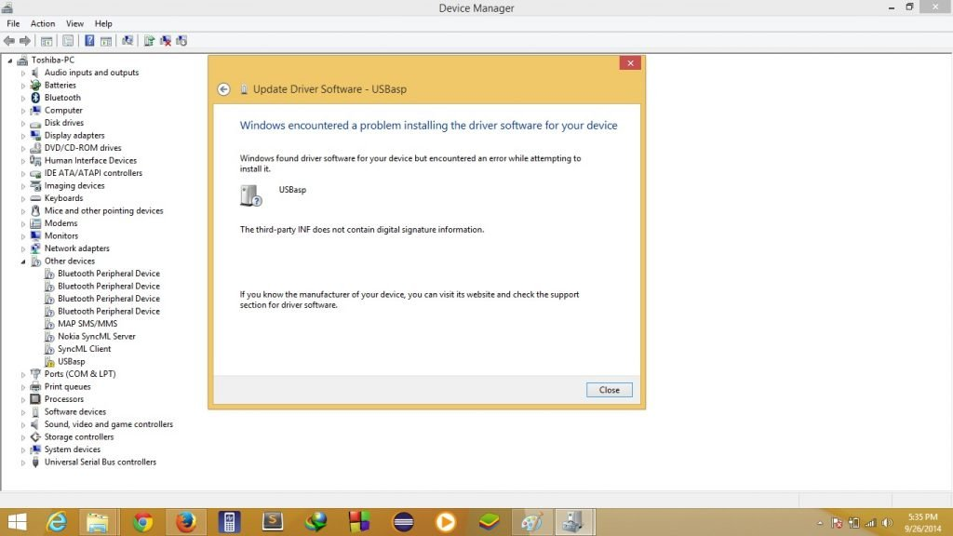

1. Next important step now we have to disable driver signature checking in Windows 8 and Windows 10, Now Hold the Shift key and restart your computer by clicking on restart button. the computer will restart with some clicking on options on your screen .so  there will be a bunch of options. when you click restart button you will see some advanced options. **click on  startup settings button.**

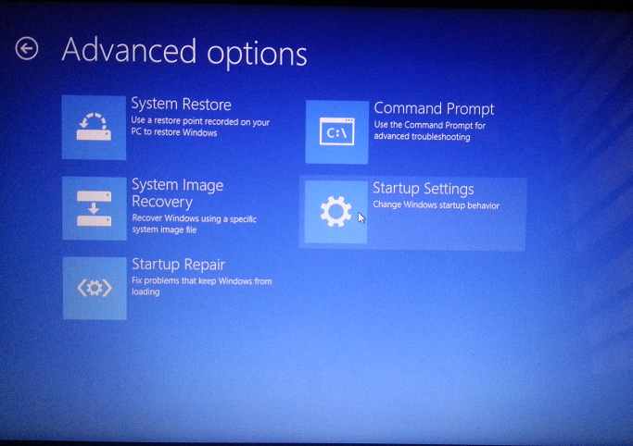

1. **Now you have to click on the option to select Troubleshoot.Click Troubleshoot button on this screen.**

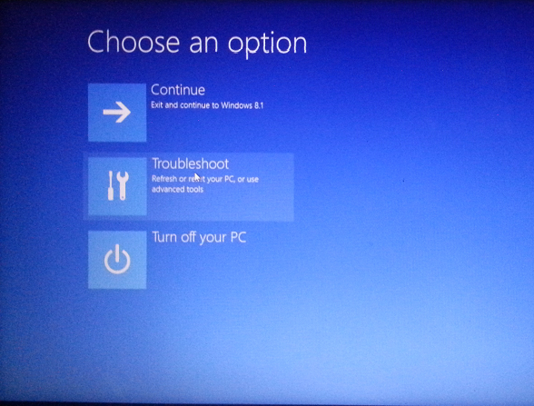

1. **when you click troubleshoot button you will see a new screen, on this screen click on the Advanced options button.**

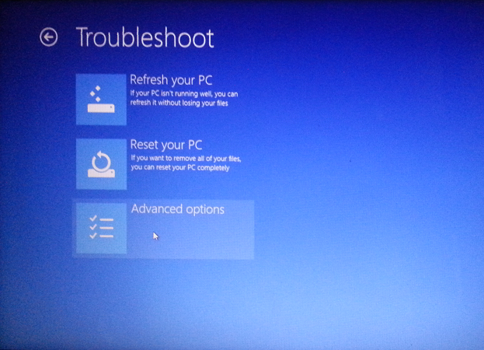

1. **After you click advanced options button on this screen you will get a new screen that will tell you that your computer will now restart after restart you will get a bunch of option for your windows. Now you simply click no restart button.**

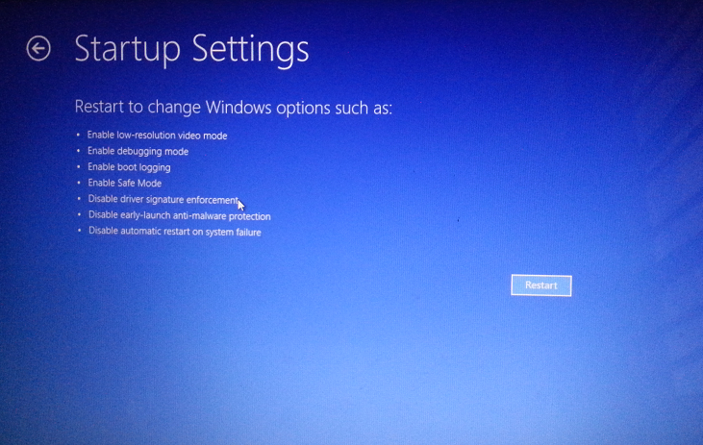

1. When your computer reboots it will show you this screen. when you see this screen after your computer restarts, you have to select **7th option ( i.e. the real option that will disable windows driver signature detection on your computer )** so now click 7 from your keyboard buttons . after that your PC will start windows normally but now with **disabled driver signature detection.**

